**Automatic Electric Power Theft Detection using Micro-controller**

****

This report submitted in partial fulfillment for the

requirements of the course of

Electronic Project Design & Development,

Course No. ETE 2200

by

**Mohammad Shihab Uddin**

**Roll:1704023**

to the

Department of Electronics & Telecommunication Engineering,

Rajshahi University of Engineering & Technology

Rajshahi-6204, Bangladesh.

**ACKNOWLEDGEMENT**

At first, my deepest gratitude to the almighty Allah that I have done the project successfully. However, it would not be possible for me without valuable support and help of many individuals. I would like to express my gratitude to all of them.

First of them, I am grateful to my respectful supervisor Md. Yeakub Ali sir for his excellent guidance and supervision , and also for helping me providing the required information and knowledge about this project. I highly appreciate his encouragement that helped me to complete the project. I would like to express my special thanks to our honorable Dr. Md. Kamal Hossain sir (head of the department of ETE) .My appreciation also goes to my beloved institution, Rajshahi University of Engineering and Technology for providing us such a opportunity to prove ourselves.

**ABSTRACT**

In this modern world , electricity is a blessing and one of the most important thing. There is good impact in economy of this electricity in modern time. So there should be a proper management system for this electricity that is being supplied to many different sector. This project is for monitoring the supplied power continuously for any purpose.This project is made up with micro-controller, sensors and LCD display which can detect any unwanted power supply and show it to the LCD display instantly . It can also calculate how much electric power is being supplied to a unexpected load in percentage.

**INDEX**

Chapter-1 Introduction..…………………………..……………..……1

1.1 Introduction About Project …………..…………………….1

1.2 Description and Circuit Operation…………….…….……..1

1.3 Application of the Project….….……………………..….….2

Chapter-2 Project Details…………………………………………...…3

2.1 Required Apparatus -………………………………….…….3

2.1.1 Atmega-328p………….…………………….……….…….3

2.1.2 ACS-712 Current Measuring sensor…………….….….….5

2.1.3 20\*4 LCD Display ……………………………..……..…..6

2.2 Software and Simulator…………..……………………..….…6

2.2.1 Atmel Studio…………………………………………...…..6

2.2.2 Proteus 8.0………….………………………………..……7

2.3 Circuit Diagram……………………………………….……...…8

2.3.1 Basic Circuit Diagram…..……………………...……….…8

2.3.2 Circuit Diagram in Simulation ………………………..…....8

2.3.3 PCB Layout…………………………………….…………..9

2.4 Working Algorithm-…………………………………..……….…10

2.4.1 LCD Display…………………………………...………….…10

2.4.2 ADC of ATMEGA-328p…………………………..………...10

2.4.3 Reading Maximum AC Current from Sensor ……..………11

2.4.4 Printing Result………………………………………..…..…12

Chapter-3 Conclusion…………………………………………………..…13

3.1 Conclusion about Project……………………………….………13

3.2 Future Updates………………………………………………..…13

**Chapter 1**

**Introduction**

**1.1 Introduction about Project**

In our daily life application , generally , we use electricity where there is no system to check out if there is an user in the same supply line which we don’t know . Thus we have to pay for that stolen power too as we don’t know about that unwanted load. This is the project to solve the problem. This is a micro-controller based project which can monitor the supplied power of a user. And if there is any unwanted power supply in the same supply line, this system can detect it automatically. This project can be divided into some parts such as, micro-controller unit (mcu), which is the center of the project. All the calculation is done and decision is taken from here, the current measuring sensor that provides the analog value to the micro- controller and the LCD display that shows the result .

**1.2 Description and Circuit Operation**

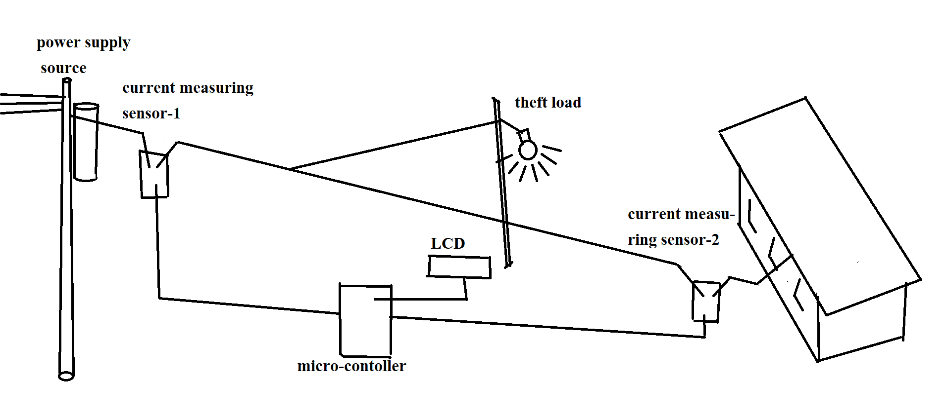

Figure 1.1- basic project diagram

In this project there are two current measuring sensor to check the if there is unknown power supply in the whole power supply line. As it is seen from the above figure, one sensor is connected in the beginning of the supply line and another one is at the end of supply line which is connected with the consumer’s house. Both sensor read the supply current value and send it to the micro-controller. Later,the micro-controller just compares those value and print the result in LCD.

**1.3 Application of the Project**

The application of this project is to prevent the unwanted power supply from the supply line. Generally there is no system to check the supplied power weather it is being supplied to the respective load or not. This project can be used there to know about unwanted connected load and how much power it is consuming.This project is suitable where there is a long power supply line with no maintenance system .For this the circuit given in this project need to connect in the power supply line as mentioned in the report and given in the circuit diagram. No isolation is required as the current measuring sensor can be connected with the electric power supply line directly. .

**Chapter 2**

**Project Details**

**2.1 Required Apparatus**

In this project , the following equipments are required

1. Hardware:

* ATMEGA-328P micro-controller (1pcs)
* ACS-712 current measuring sensor (2 pcs)
* 20\*4 LCD display(1 pcs)

1. software:

* Atmel Studio
* Proteus design suite

##### 

##### **2.1.1 ATMEGA 328p**

##### The Atmel [8-bit](https://en.m.wikipedia.org/wiki/8-bit" \o "8-bit) [AVR](https://en.m.wikipedia.org/wiki/Atmel_AVR" \o "Atmel AVR) [RISC](https://en.m.wikipedia.org/wiki/Reduced_instruction_set_computing" \o "Reduced instruction set computing)-based micro- controller combines 32  KB [ISP](https://en.m.wikipedia.org/wiki/In-system_programming" \o "In-system programming) [flash](https://en.m.wikipedia.org/wiki/Flash_memory" \o "Flash memory)

##### memory with read-while-write capabilities.

##### It has 1 KB [EEPROM](https://en.m.wikipedia.org/wiki/EEPROM" \o "EEPROM), 2 KB [SRAM](https://en.m.wikipedia.org/wiki/Static_random-access_memory" \o "Static random-access memory), 23 general purpose I/O lines, 32 general purpose working [registers](https://en.m.wikipedia.org/wiki/Processor_register" \o "Processor register), three flexible timer/[counters](https://en.m.wikipedia.org/wiki/Counter_(digital)" \o "Counter (digital)) with compare modes, internal and external [interrupts](https://en.m.wikipedia.org/wiki/Interrupt" \o "Interrupt), serial programmable [USART](https://en.m.wikipedia.org/wiki/USART" \o "USART), a byte-oriented 2-wire serial interface, [SPI](https://en.m.wikipedia.org/wiki/Serial_Peripheral_Interface_Bus" \o "Serial Peripheral Interface Bus) serial port, 6-channel 10-bit [A/D converter](https://en.m.wikipedia.org/wiki/A/D_converter" \o "A/D converter) programmable [watchdog timer](https://en.m.wikipedia.org/wiki/Watchdog_timer" \o "Watchdog timer) with internal [oscillator](https://en.m.wikipedia.org/wiki/Electronic_oscillator" \o "Electronic oscillator), and five software selectable power saving modes. The device operates between 1.8-5.5 volts. The device achieves throughput approaching 1 [MIPS](https://en.m.wikipedia.org/wiki/Million_instructions_per_second" \l "Million_instructions_per_second" \o "Million instructions per second)(million instructions per second) per MHz.

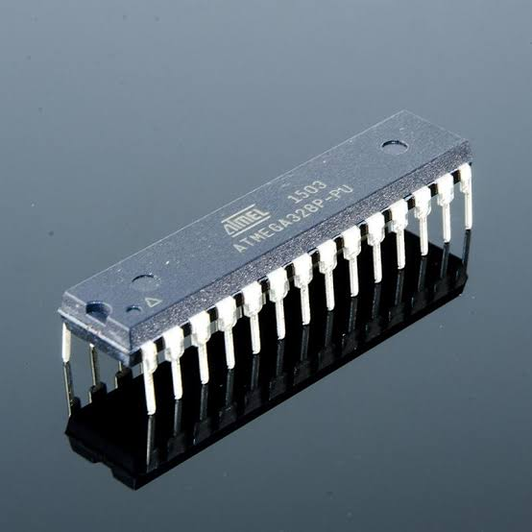

Figure 2.1: ATMEGA-328p

The pin diagram of ATMEGA-328p is given bellow:

##### **Annotation 2020-11-29 190029**

Figure 2.2- ATMEGA-328p pin diagram

##### 

In this project , 2 ADC pins are used for reading the value of 2 current measuring sensors. Total 11 pins of micro-controller are connected with LCD to drive the LCD. Also the reset pin is connected with a push button to reset the micro-controller.

**2.1.2- ACS-712 Current Measuring Sensor**

The ACS-712 is a hall effect based linear current measuring sensor. There are some varieties of this sensor based on the range of measuring current. Pin 1 or 2 is connected with the positive terminal of supply line and Pin 3 or 4 is connected with the negative terminal of supply line. Pin 8 and 5 are for supplying 5 volt of power to the sensor. The output of the sensor is supplied from pin 7

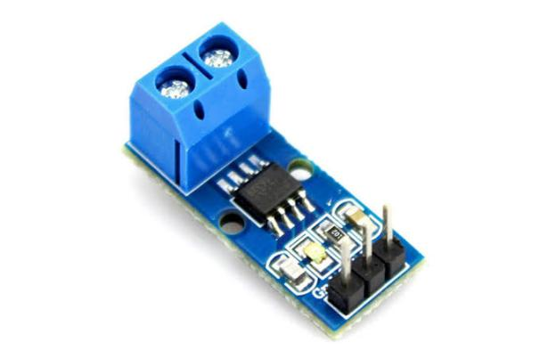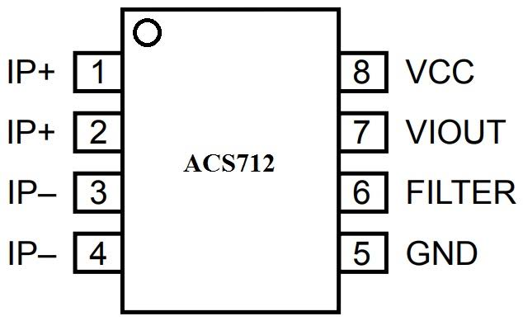

Figure 2.3: ACS-712 current measuring sensor and its pin diagram

In this project this current measuring sensor can measure up to 10 amperes .The output characteristics graph of the sensor is given bellow:

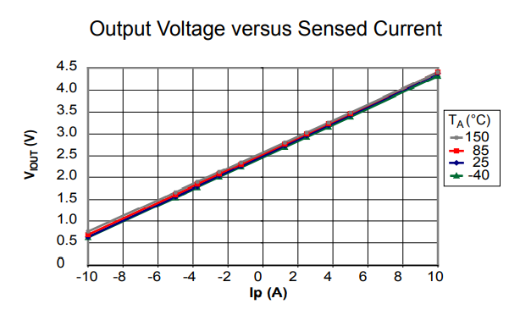

Figure 2.4- sensed current vs output voltage characteristics

As we can see ,the output voltage of this sensor will be maximum (5 volts ) when it senses the maximum current (10 amps ). Again, at no load current , the sensor will provide the output voltage 2.5 volts.

**2.1.3 -20\*4 LCD**

The most commonly used Character based LCDs are based on Hitachi’s HD44780 controller or other which are compatible with HD44580. This is a character based LCD which interfaces with various micro-controllers. In the LCD there are 8 data pins(D0-D7) and 3 control pins (RS, RW and E) .

It can be programmed in two ways based on data pins. Those are 4-bit and 8-bit. In this project 8-bit mode has been used. The LCD display it’s pin diagram are given bellow:

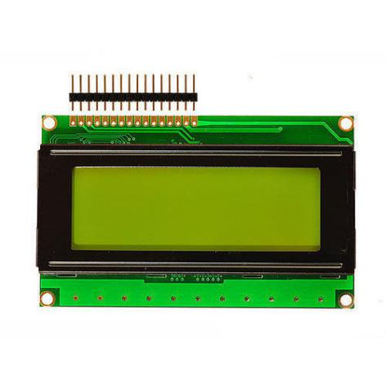 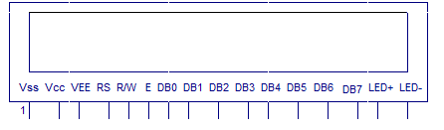

Figure 2.5: 20\*4 LCD display and it’s pin diagram

**2.2 Software and Simulator**

As it is a micro-controller based project, two software have been used here . One is Atmel studio, which is used to create hex file for the micro- controller. Another one is Proteus design suite which is a circuit simulator with a huge library.

**2.2.1 Atmel Studio**

Atmel Studio is a integrated development platform from Microchip. It has a environment to write, build and debug applications written in C/C++ or assembly code to create the required HEX file or debug file which is burned into micro-controller. It is an integrated development platform (IDP) for developing and debugging all AVR and SAM micro-controller applications. Additionally, it can also import Arduino sketches as C++ projects.

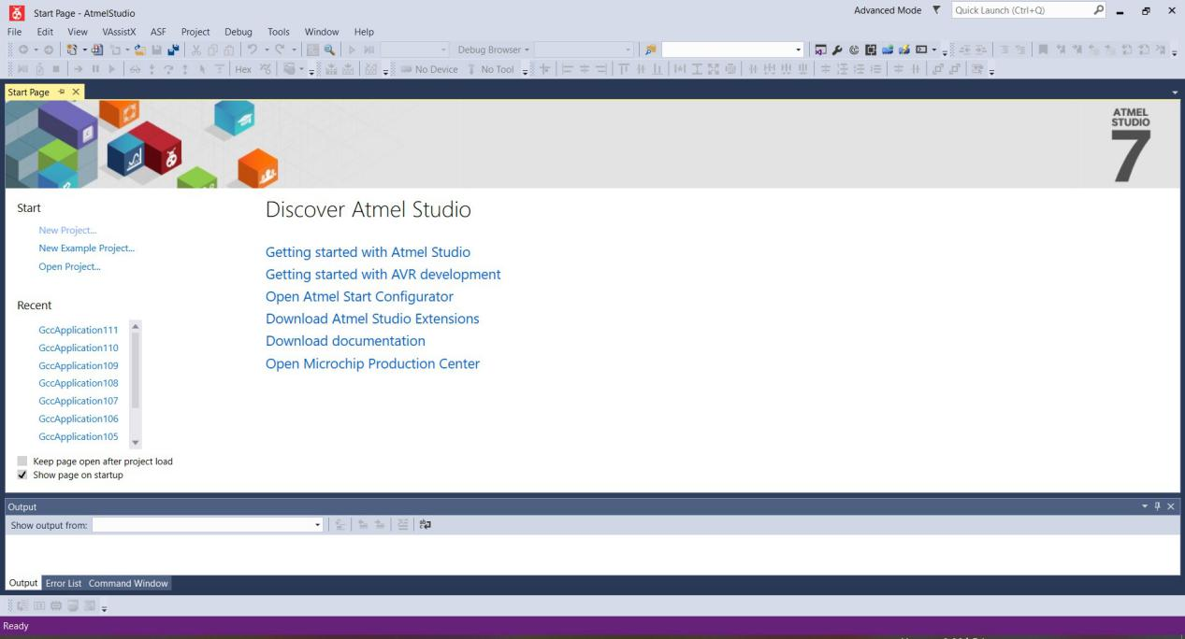

Figure 2.6:Atmel studio

**2.2.2 Proteus 8.0**

The Proteus Design Suite by Labcenter Electronics Ltd is a proprietary software tool used primarily for electronic design automation. it is used mainly to create schematics and simulate the electronic circuit . The PCB design for that circuit also can be done here.

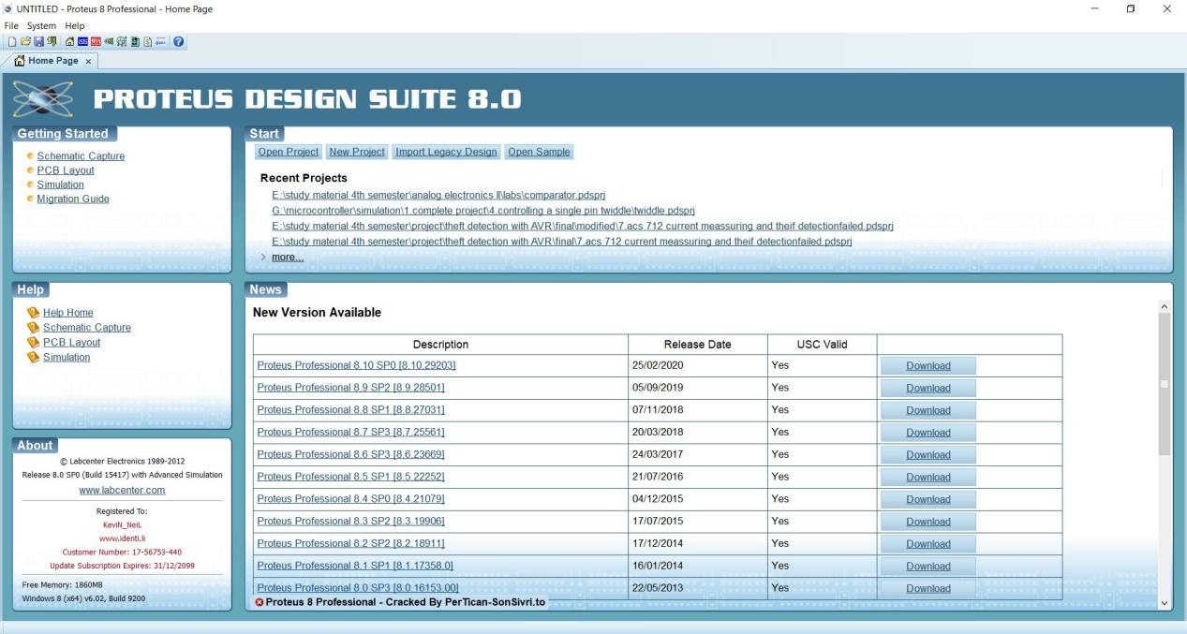

Figure 2.7: Proteus 8.0

In schematic capture, one can create the circuit using micro-controller such as AVR, PIC, ARM etc. All is need to apply the required hex file or debug file into the micro-controller for the real time simulation. Later the PCB layout of that same circuit can be created too. One can view the 3D model of the PCB with the components too.

**2.3 Circuit Diagram**

From the circuit diagram , it can be seen how the components are connected with each other and how they works

**2.3.1 Basic Circuit Diagram**

Basic circuit diagram shows how the pins are connected with the component each other. Every component represented here is according to their pin diagram. All the component used here are powered by 5 volt DC supply. Two current sensors and one LCD display are connected with micro-controller directly. Total 15 pins of the micro-controller have been used in this project.

**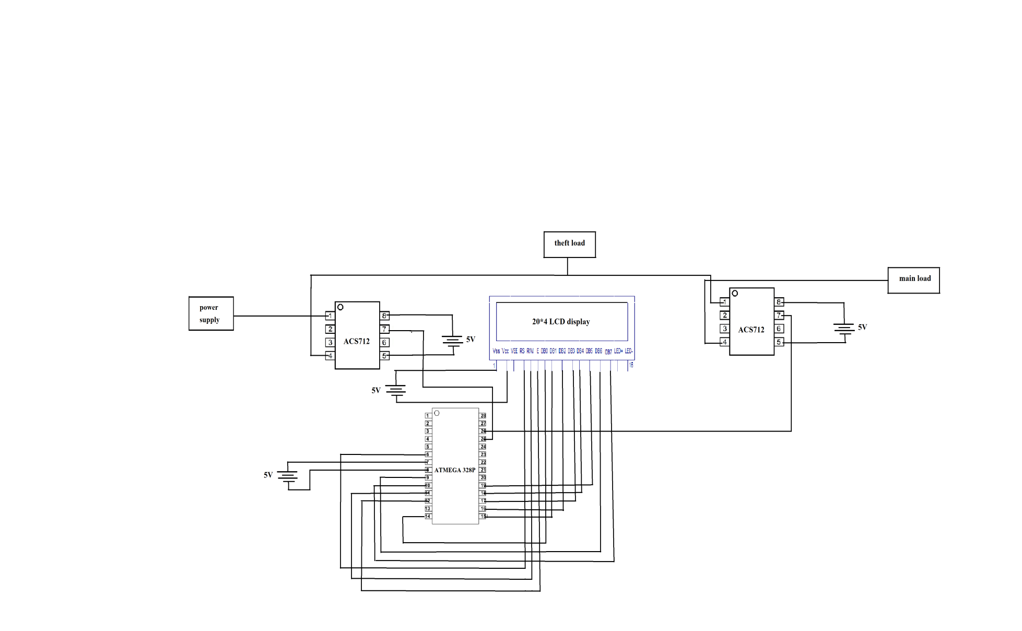**

Figure 2.8: basic circuit diagram

**2.3.2 Circuit Diagram in Simulation**

As it mentioned earlier, **Proteus 8.0** is used as circuit simulator. In this project, this proteus has been selected as simulator. Here, a series connection of LED and resistor are used as load. As LED is a DC load , a diode is connected paralelly and worked as half bridge rectifier.The consumer load is connected at the end of supply line, and the theft load is connected with a supply line through a switch. One ACS-712 sensor is connected at the beginning of the power supply line, another one is connected at the end of the line. Analog value from sensor can be read as they’re connected with ADC2 and ADC3 pin.Total 11 pins of micro-controller are connected with the LCD module.

As the LCD is programmed here in 8 bit mode, PB0-PB7 are connected with 8 data pins of LCD. And PD4-PD6 pin are connected with another 3 pins of LCD to control the command and data given from micro-controller. Two of loads are used here using LED and resistor. One of them is consumer’s load which is connected at the end of power supply line, another one is theft load which is connected at the middle of supply line.

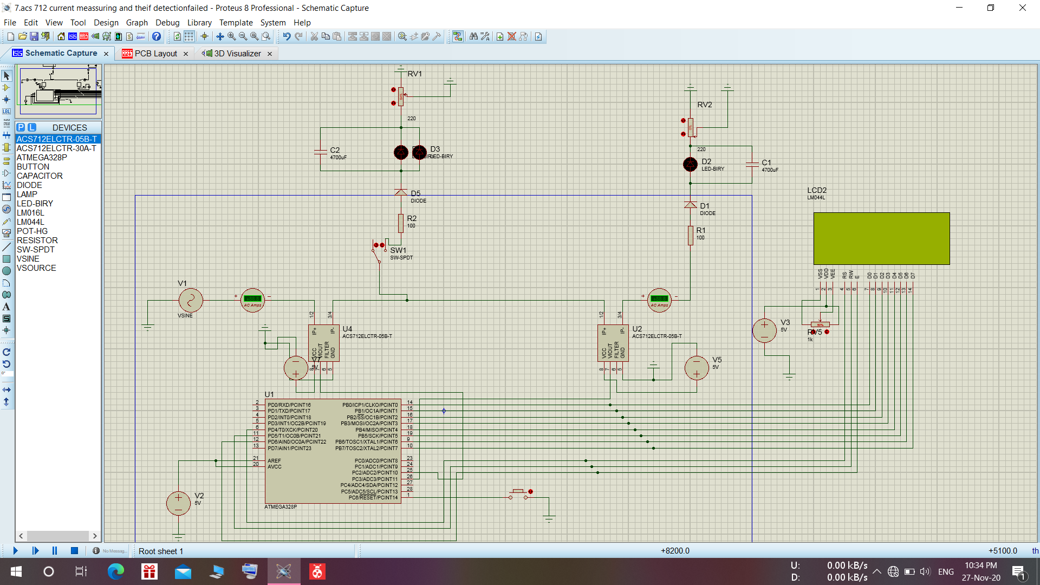

Figure 2.9: circuit diagram in simulation

**2.3.3 PCB Layout**

The PCB layout of this circuit has been done using same Proteus simulator . The PCB layout of the mentioned circuit is given bellow. As there are some cross connecting route in the circuit, they will be connected externally in the circuit . Each of the component is powered by 5 volt DC supply. All the ground pins are connected together. Finally there are total four pins for the connection with the power supply line and sensors.

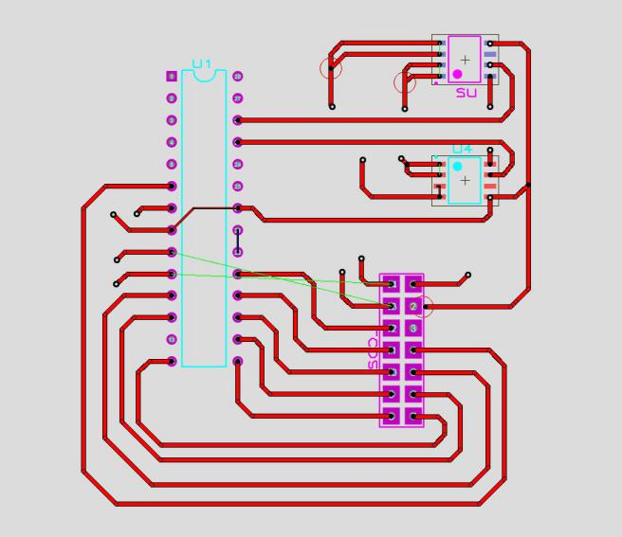

Figure 2.10 : PCB layout of the circuit

**2.4-Working Algorithm**

The project works based on following steps :

1. Read the value from two current measuring sensors
2. Convert those analog value into digital value
3. Compare the value of two current sensors .
4. If (supply current > load current ), go to step 5 otherwise go to step 6
5. Print in LCD , theft load detected , also print the consumed power and go to step 7.
6. Print in LCD ,No theft load detected.
7. Repeat all the steps

**2.4.1 LCD Display**

In LCD ,data pins are used for sending data to LCD from micro-controller. 5 volt of DC power supply is required for LCD display used in the project. Before sending data to LCD, there are some commands needed to send to LCD to initialize it. Commands are sent through the same data pins. And sending data or command is controlled by those three pins (RS, R/W and E). here,RS=0; RW=0; EN=1 for sending command and RS=1; RW=0; EN=1 for sending data. The contrast of the LCD can be controlled by varying the pot connected with the LCD.

**2.4.2 ADC of ATMEGA-328p**

ADC is a process to convert analog value into digital value . As the sensor provide the analog signal and the micro-controller is only capable of binary operation, ADC is required here. In atmega-328p, there is a 10 bit ADC hardware, which can convert the analog value of signal into 10 bit of binary value. The register whose control this ADC operation mainly are, ADMUX and ADCSRA. The converted ADC value is stored in 2 register ADCL(8 bits) and ADCH(2 bits).

**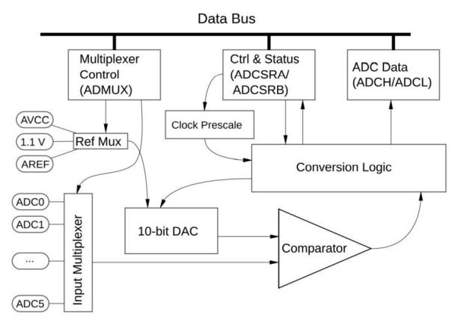**

Figure 2.11: ADC block diagram of ATMEGA-328p

**2.4.3 Reading Maximum AC Current from Sensor**

As it mention earlier , there are 2 current measuring sensors in this project. Both sensor measures the current value in same way. As in this project, the current is being measured from AC power supply line. There is no chance to get a fixed value from the sensor as it is changing continuously. So, the peak value of the current has been measured. Again the peak value of current can be changed too as the current depends on load

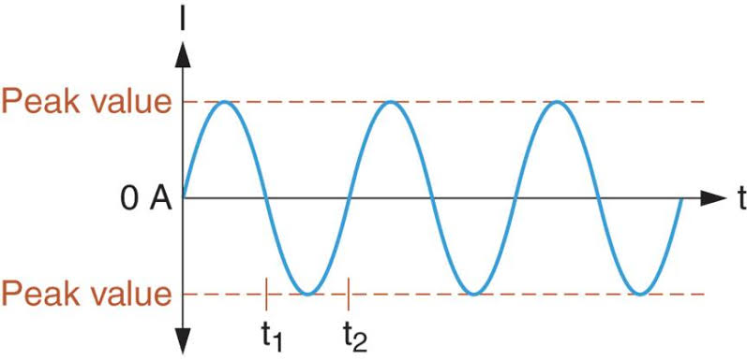

Figure 2.12: waveform of AC current

The peak value of the AC current can be measured by following way:

Int const=0 //let a constant value 0 for comparison

for(i=0; i<200; i++){

Current\_value = read\_analog\_sensor\_value();

if (current\_value>const)

{

const= current\_value;

}

}

Return (const)

Hence it can be measured the peak(maximum) value of the current sensed by the sensor.

**2.4.4 Printing Result**

The final output of the project can be seen in this part. Let the current measured by two sensors are

SC = source current which is from the beginning of the power supply line

LC= load current which is from the sensor connected with load.

Wasted = Consumed power by theft load;

If( SC = LC){ // no current is flowing through another line

Print (“ no theft load detected”);

}

Else if(SC>LC){ // current is flowing through another line

Print(“ theft load detected”);



Print(“wasted power is , %d”, wasted);

}

**Chapter 3**

**Conclusion**

**3.1 Conclusion about Project**

The main purpose of this project was detecting unwanted load in the supply line. In this project both hardware and program has been used. In the hardware part , two sensors and a micro-controller have been used. The programmed hex file was uploaded into the micro-controller to run the whole project properly. The consumer’s load in the project has been connected through a switch as well as the theft load for checking purpose.

There were some error while simulating the project. It was due to the component package used in the simulator. The error was occurred while showing the percentage of the consumed power by the theft load( almost 4%) .All the circuit components and the circuit has been explained properly. Also the code used in the project has been explained properly. The PCB layout of the circuit has been created from the same circuit used in the project.

**3.2 Future Updates**

There are some features of this project that should be modified.One of them is , the connection between current measuring sensors and the micro-controller. There should be a wireless connection between current measuring sensor and micro-controller using wi-fi module.